Team Name: Vertex Analytics (Grad Group 20)
Team Members:
Da Zhang (V01062902)
Yuanming Wang (V01028720)
Yafei Fan (V01087635)
Tan Dai Ngo (V01073190)

AI Customer IT Support Ticket Classification, Prioritization, and Routing System

Summary of Work Completed to Date
Our project aims to automatically classify customer support tickets by ticket type, priority, and destination queue. So far, we have completed the main data preparation and established a baseline for all three prediction tasks. We combined each ticket’s subject and body into one text field and examined the label distributions, missing values, and ticket lengths. The processed English dataset currently contains 16,338 tickets with four ticket types, three priority levels, and ten support queues.

For the baseline, we used TF-IDF features followed by Logistic Regression with balanced class weights. We also included a most-frequent dummy classifier to confirm that the model was learning useful patterns rather than only predicting the class in which the vectorized texts appeared most frequently.

We are now testing a stronger text model. We use BERT to convert each ticket into a 768-dimensional contextual embedding, then train a feed-forward neural network for each target. A genetic algorithm is used to search for suitable neural network settings, including hidden layer size, activation function, regularization strength, and learning rate. The fitness of each candidate is evaluated through 3-fold cross-validation. We have also generated classification reports and confusion matrices to study errors for individual classes.

Challenges Encountered
The main challenge is that the accuracy is still lower than we expected, especially for priority and queue prediction. Many tickets use similar formal language even when they belong to different classes. Priority is also difficult because urgency may be implied rather than directly stated.

Queue prediction is particularly challenging because it contains ten different classes. Several queues have similar responsibilities and vocabulary, especially Customer Service, IT Support, Product Support, and Technical Support. As shown in the confusion matrix, tickets from these categories are frequently misclassified as one another. For example, many IT Support and Product Support tickets are predicted as Technical Support, while Customer Service tickets are often confused with Product Support or Technical Support. This suggests that the boundaries between these queues are not always clear from the ticket text alone.
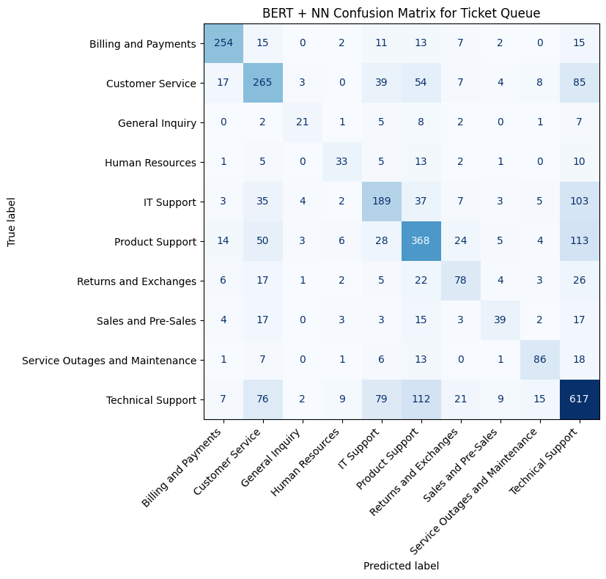
The class distributions are also not fully balanced. For example, the processed dataset contains 4,737 Technical Support tickets but only 236 General Inquiry tickets. The low priority class is also much smaller than the high and medium priority classes. This makes it harder for the models to learn minority classes reliably.

Preliminary Results
The Logistic Regression baseline was tested on the processed English dataset of 16,338 tickets. It achieved 84.5% accuracy for ticket type, 60.4% for priority, and 50.0% for queue prediction.
The current BERT embedding and neural network models were tested on the same dataset. The ticket type model achieved 88.0% test accuracy and a weighted F1-score of 0.878. The priority model reached 69.2% accuracy, with an F1-score of 0.677. The queue model reached 59.7% accuracy, with an F1-score of 0.572.

These results are encouraging, but performance remains uneven across classes. For example, the type model still confuses some Incident and Problem tickets, while the queue model has difficulty separating related technical support categories.

Discussion
The preliminary results suggest that BERT embeddings capture the meaning of ticket text more effectively than the TF-IDF Logistic Regression baseline. However, the improvement is not equally great for all tasks. Ticket type classification performs relatively well, while priority and queue prediction remain more difficult because of class imbalance, overlapping vocabulary, and unclear boundaries between related support queues.

Our next step is to build additional machine learning models using the same TF-IDF text features. We will first implement TF-IDF models using both linear SVM and kernel SVM. The linear SVM is well suited to high-dimensional and sparse text features, while the kernel SVM will allow us to examine whether nonlinear decision boundaries can better separate similar ticket classes.
We will then develop a TF-IDF with a k-nearest neighbours model using cosine similarity. We believe cosine similarity is suitable for text classification because it compares the direction of TF-IDF vectors rather than their magnitude, allowing the model to retrieve tickets with similar word patterns even when their lengths differ.

All models will be evaluated using the same processed dataset, train-test split, and performance metrics to ensure a fair comparison. We will compare accuracy, precision, recall, F1-score, and confusion matrices, with particular attention to minority classes and the four frequently confused queues. Moreover, if time permits, we will develop a live demo based on the best-performing model to demonstrate how this text classifier works in practice.

